**How do you remove “Keep Changes” Prompt in LABEL MATRIX from appearing after print job?**

**3195**

**Problem**

* **How do you remove “Keep Changes” Prompt in LABEL MATRIX from appearing after print job?**

**Environment**

* **Microsoft Windows XP**
* **Microsoft Windows Vista**
* **Microsoft Windows 7**
* **Microsoft Windows Server 2003**
* **Microsoft Windows Server 2008**
* **Microsoft Windows Server 2012**
* **Microsoft Windows 8**

**Resolution**

**For all Counters or Keyboard input fields on the label follow these steps**

1. **Right-click and go to Properties**
2. **Under Keyboard Tab click the Advanced... button**
3. **In the Advanced menu change the drop-down for Keep Changes to ‘Yes’ or ‘No’  
     
   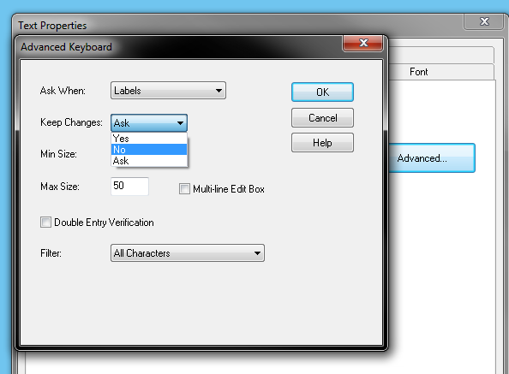**
4. **Click OK and repeat as needed  
     
   N.B.   
   Please note that this process will need to be applied for all Keyboard input variables on a label template.**

**Cause**

**LABEL MATRIX defaults the Keep Changes option to ‘Always Ask’. The prompt will always appear after printing unless defined as ‘Yes’ or ‘No’**

**Always Ask – The software ALWAYS prompts for a decision**

**Yes – Always saves the changes**

**No – Never saves the changes**